1. Write Java code that print the following sequences of values in loops:
a) 24, 18, 12, 6, 0
b) -10, -5, 0, 5, 10, 15
c) 18, 27, 36, 45, 54

2. Write a program that calculates and prints the sum of the even integers from 10 to 60.

3. Write a program that calculates and prints the product of the odd integers from 3 to 13.

4. Write a y program that will calculate the value of y if the expression of y is as follows (n is the input):

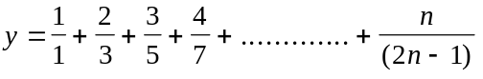

5. Write a Java program that will calculate the value of y if the expression of y is as follows (n is the input):

6. Write a Java program to compute and display a person’s weekly salary as determined by the following conditions:
If the hours worked are less than or equal to 40, the person receives Tk200.00 per hour, else the person receives Tk8000.00 plus Tk300.00 for each hour worked over 40 hours.
The program should request the hours worked as input and should display the salary as output.

7. Write a Java program that performs four functions of a calculator. The program should request the user to enter a floating-point number, an operator and another floating-point number. It should then carry out the specified arithmetical operation: adding, subtracting, multiplying, or dividing the two floating-point numbers. Finally, it should display the result.

8. A student will be placed on probation if his CGPA falls below 2.0 in an exam. Write a Java program that reads a student’s CGPA from the standard input and prints on the standard output whether he is on probation or not.

9. Write a program that reads an integer and extracts and displays each digit of the integer in English. So, if the user types in 451, the program will display four five one.

10. Write a Java program that reads marks of ten courses and prints the maximum, minimum and average of those ten marks.

11. Suppose the following expressions are used to calculate the values of L for different values of S:

L = 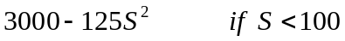
L = 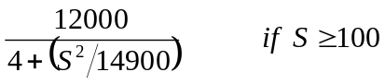

Write a Java program that reads a value of S and then calculates the value of L.

12. Write a C program that reads the value of n and calculates the value of y if the expression of y is as follows:

13. The current in an alternating current circuit that contains resistance, capacitance, and inductance in series is given by
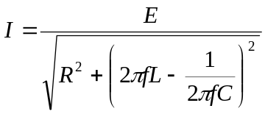
Where I=current (amperes), E=voltage (volts), R= resistance (ohms), L= inductance (henrys), C= capacitance (farads) and f=frequency (hertz). Write a Java program that reads values for the voltage, resistance, inductance, capacitance and frequency, and then calculates and displays current.

14. Suppose the following expressions are used to calculate the values of P for different values of Q:

P = 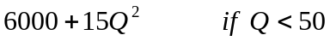
P = 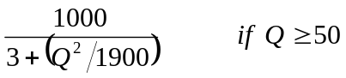

Write a C program that reads a value of Q and then calculates the value of P.

2. Write a C program that reads the values for the three sides x, y, and z of a triangle, and then calculates its area. The area is calculated as follows: 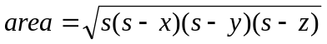
where s is 